**LJMU 2017-18 3is programme**

All sessions will take place at Exchange Station, Tithebarn Street, Liverpool, L2 2QP. Please ensure you read the **‘Access’** instructions below for entry information.

**Listed below are the dates and sessions you are booked on to.**

**Day One:**

**Monday 6th November**

10.00am – 12.00pm         INDUCTION

1.00pm – 3.30pm              PLANNING FOR LEARNING

**Day Two:**

**Tuesday 7th November**

10.00am – 12.00pm         SMALL GROUP TEACHING

1.00pm – 3.30pm              WORKING WITH LARGE GROUPS

**Day Three:**

**Monday 13th November**

1.30pm – 3.30pm         INTRODUCTION TO ASSESSMENT

**Day Four:  
Please note, I will send you a separate email shortly in relation to your Microteaching date with full information about the requirements for this session.**

**[VARIOUS DATES]**

10.00am – 1.00pm         MICROTEACHING

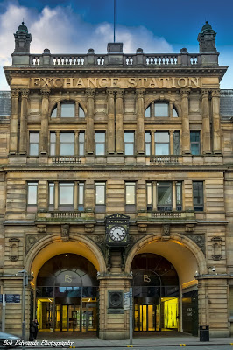**Please take some time to read further information below – thank you:**

**Access**

All sessions will take place in Room G14, Ground Floor, at Exchange Station, Tithebarn Street, Liverpool, L2 2QP. A map of the buildings location will be available on Googlemaps. We have included a photograph of the front of the building here:

**\*\*PLEASE READ ACCESS INFORMATION BELOW\*\***

In order to obtain entry to the building, you will need to ensure you are **wearing** your LJMU card. As you enter the building, approach the main reception on the right hand side. This is the central reception for the entire building. Inform them that you are attending an LJMU training course and need access to the LJMU reception. They will direct you to a set of barriers on the right hand side. They will open these barriers for you. Upon going through these barriers, go up the small flight of stairs, turn to your right and go through the door. You will see an LJMU reception desk in front of you. Please inform the receptionist that you are attending 3is training and they will direct you to the correct room.

Please note you will need to wear your badge at all times.

If you have any access requirements do please let us know.

**Travel and Car Parking**

The nearest train station to Exchange Station is Moorfields. There are a range of NCP pay and display car parks available in the vicinity of Exchange Station: Moorfields and Pall Mall. There are two smaller car parks on Tithebarn Street and Highfield Street.

**Refreshments and Lunch**

There will be tea and coffee available at registration (the first session of each day) only. There are water machines available in the training room. A sandwich lunch will be provided on Monday and Tuesday only. If you have any special dietary requirements can you please let me know as soon as possible so these can be accommodated.